******BMA Scottish GP Committee/ Scottish LMC Update – September 2021**

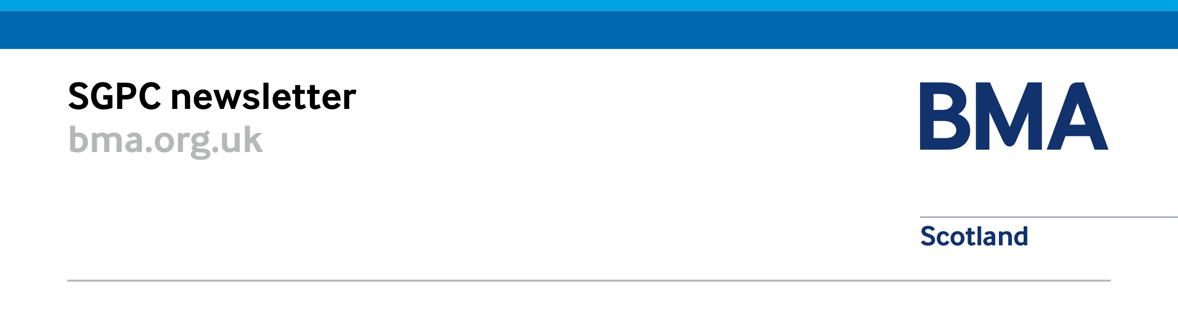

# BMA Scottish GP Committee (SGPC) Update:

## **BMA SGPC Meeting – 19 August 2021**

### Expanded Primary Care Multi-Disciplinary Team Survey

The BMA Scottish GP Committee launched a survey at the end of June that closed on 7 July 2021, to understand to what extent GPs have access to the MDT outlined in the GMS contract (2018).

A total of **340 practices** responded to the survey and these returns are being analysed alongside other available information to understand what they tell us about implementation of the contract throughout the country.

### BMA SGPC Meeting – 19 August

The BMA Scottish GP Committee (SGPC) met on 19 August 2021 which discussed the [revised MoU](https://www.sehd.scot.nhs.uk/publications/Memorandum_of_Understanding%202-GMS_Contract_Implementation_for_PC_Improvement%2030_July_2021.pdf); results of the expanded multidisciplinary team survey, the DDRB recommendations and Scottish Government announcement of 3% for all doctors; the National Care Service Consultation; the SPPA practitioner contribution issues; the upcoming elections for the office bearer SGPC posts, and an announcement that Dr Andrew Buist was re-elected uncontested for another 3 year term (2021-2024) to the position of chair of SGPC.

The committee again discussed local rollout of the Redesign of Urgent Care work, the future of COVID-19 community pathways and received various reports on Sessional GP and GP Trainee issues. SGPC also heard updates on premises, IT, GP Wellbeing, GP medical appraisal and pensions.

### Premises

A National Primary Care (GP) Premises Group meeting was held on 12 August 2021 which discussed lease assignations, loan offers, and premises directions. The next meeting of the group is 4 November 2021. LMCs were asked to inform SGPC if practices had not received the results of the recent GP Premises Survey, or if they had any issues with their results.

## **Negotiating Issues and Contracts**

### Memorandum of Understanding 2

BMA SGPC, Scottish Government, Integration Authorities and NHS Boards have agreed the [revised Memorandum of Understanding](https://www.sehd.scot.nhs.uk/publications/Memorandum_of_Understanding%202-GMS_Contract_Implementation_for_PC_Improvement%2030_July_2021.pdf) to implement the 2018 GMS contract.

The central purpose of the MOU remains the implementation of the 2018 contract and specifically the transfer of the provision of ‘MOU services’ from general practice to HSCP/Health Boards.

The MOU reflects our previous agreements with Scottish Government to:

* Establish in Regulations that Integrated Joint Boards/Health Boards are responsible for providing vaccination, pharmacotherapy and Community Treatment and Care services to patients and GP practices.
* That SG and SGPC will negotiate transitionary service arrangements for practices that support IJBs/HBs with the routine delivery of MOU services after 1 April 2022.  We have committed to developing the principles for how transitionary services and payment arrangements will work by the end of Summer 2021.

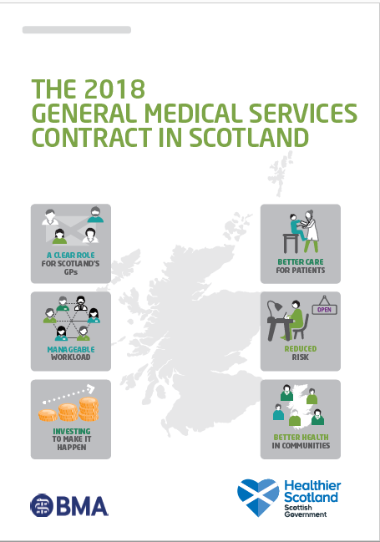

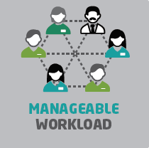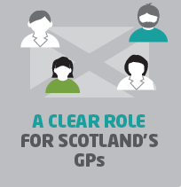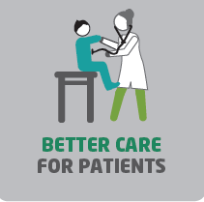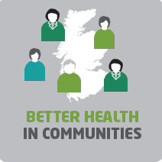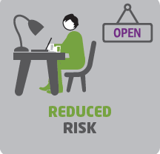

### Flu Vaccine Programme Update

BMA SGPC and Scottish Government have attempted a balance of a protective national backstop arrangement – while still providing clear flexibility for local solutions and promoting progress with the VTP. Health boards are to consider at the outset whether they are now able to fully transfer delivery away from GPs and are encouraged to do so if they can. Where boards deliver the entire programme GP historical vaccine income is protected. Further details are available online: ‘[PCA2021(M)07 Influenza and Pneumococcal Temporary Enhanced Service’](https://www.sehd.scot.nhs.uk/pca/PCA2021(M)07.pdf)

## **Finance – Pensions, Pay Announcement and GP Uplift 2021-22**

### Pensions

The Scottish Public Pensions Agency (SPPA) has been criticised for errors impacting on its members which include teachers, police, firefighters, and NHS staff. It appears than many practitioner members have been asked for contributions that have led to either over or under funding of their pension.

SGPC has been alerted of the situation however are still awaiting full figures of those impacted by the issue. SGPC has met with SPPA to begin to understand what has gone wrong, to ensure that the issue is resolved as quickly as possible, and to minimise any disadvantage to GPs.

### Pay Announcement and GP Uplift 2021-22

A 3% pay increase has been announced for all doctors backdated to April 2021. The Scottish Government has advised that their intention is for the uplift for practices to be sufficient to allow for a 3% increase to GP income, a 4% increase to non-GP staff pay and a 1.9% increase for other expenses.

Further details are available in the [GP Uplift 2021-22 letter](https://www.sehd.scot.nhs.uk/pca/PCA2021(M)08.pdf). SGPC would encourage and expect practices to deliver the agreed pay increase of 4% to their staff. All practices should receive their uplift in the September payment. A blog has also been published by deputy chair Patricia Moultrie and is available [online](https://bmascotland.home.blog/2021/08/23/pay-update-for-gps/).

## **Workload and Wellbeing**

### GP and Staff Wellbeing Resources – [Workforce Specialist Service](https://www.practitionerhealth.nhs.uk/accessing-the-service-in-scotland)

The Workforce Specialist Service has been offering advice and support for regulated professionals working across the NHS and social care sectors.

A detailed analysis to monitor and evaluate how the service is working is currently underway on whether it meets the needs of doctors. Headline figures were shared in Patricia Moultrie, deputy chair’s blog – [Requests for help through workforce support service likely to be ‘tip of the iceberg’](https://bmascotland.home.blog/2021/06/28/requests-for-help-through-workforce-support-service-likely-to-be-tip-of-the-iceberg/) ,posted on 28 June, in the first 6 months of the service opening there were 150 registrations were made to the services, 81 were doctors and 49 were GPs.

In the meantime, if you or a colleague would benefit from access to the Workforce Specialist Service, you can find full details of this service [**here**](https://www.practitionerhealth.nhs.uk/accessing-the-service-in-scotland). If you do need to use it, please complete both the registration forms and wellbeing questionnaires available [**HERE**](https://www.smartsurvey.co.uk/s/NHS_SWSS/) – it is essential that you complete both sets of forms to register for the service and ensure you are provided with the support you need. If you have any difficulties accessing or completing the forms or would prefer to speak to someone in the service, please call **0300 0303 300.   
(Mon– Fri 8am-8pm, Sat 8-2pm).**

## **COVID-19 Recovery and Remobilisation**

### NHS Recovery Plan

The [NHS Recovery Plan](https://www.gov.scot/publications/nhs-recovery-plan/documents/) was published by Scottish Government on 25 August 2021, which sets out key ambitions and actions to be developed and delivered now and over the next 5 years in order to address the backlog in care and meet ongoing healthcare needs for people across Scotland. BMA Scotland has provided a [response to the NHS Recovery Plan online](https://www.bma.org.uk/bma-media-centre/bma-scotland-response-to-nhs-recovery-plan) and our deputy chair, Andrew Cowie has also produced a [blog in response](https://bmascotland.home.blog/2021/08/26/the-vicious-circle-damaging-gps-has-to-stop/).

## **National Care Service Consultation**

### National Care Service Consultation

The Scottish Government has launched a [consultation](https://www.gov.scot/publications/national-care-service-scotland-consultation/) on proposals for a National Care Service for Scotland on 9 August 2021. The paper sets out proposals to improve the way social care in Scotland is delivered, following the recommendations of the Independent Review of Adult Social Care. We would encourage all LMCs to read and respond to the consultation which closes on **2 November 2021** includes a recommendation that “*IJBs should manage GPs’ contractual arrangements*”. BMA Scotland will be providing a response in due course.

## **Information Management and Technology**

### Scottish Joint GP IT Group

The thirteenth meeting of the Scottish Joint GP IT Group will be held on 29 Sept, with discussions on the [Primary Care Digital IT letter 2021-22](https://www.sehd.scot.nhs.uk/publications/primary_care_digital_improvement_2021-22.pdf) issued on 13 July 2021; a review of the terms of reference of SJGPITG; an update on the National Workforce Reporting System; and on Digital Asynchronous Consulting Solutions (DACS).

The SJGPITG will also hear updates from the Primary Care Reform Digital Board, NHS Education for Scotland -National Digital Services (NDS), Scottish National Users Group (SNUG), Systematised Nomenclature of Medicine – Clinical Terms (SNOMED-CT), and Primary Care Informatics (new SCIMP).

# LMC Update: For information

### Chair Elections for BMA Scottish GP Committee

The elections for BMA Scottish GPC Chair (Sessions 2021-24) have concluded. I am pleased to announce that Dr Andrew Buist has been elected uncontested for another 3 session term.

### SGPC Representatives, First of Session and Office Bearer Elections for BMA Scottish GP Committee

A reminder that the election process for **deputy chair, co-negotiator, SGPC executive** will take place in September in advance of the first of session meeting on **28 October 2021**.

If your LMC has already elected SGPC representatives for session 2021-22 we would request you to send details to Mhairi Weatherston ([mweatherston@bma.org.uk](mailto:mweatherston@bma.org.uk)) at your earliest convenience to ensure inclusion in the elections process.

Newly elected SGPC members for Session 2021-22 are the electorate and eligible nominees for SGPC office bearer – deputy chair, co-negotiator and SGPC executive election positions, and will be contacted by secretariat in due course. Dates for next session of BMA SGPC meetings (2021-2022) are available on the [SGPC webpage](https://www.bma.org.uk/what-we-do/committees/general-practitioners-committee/scottish-general-practitioners-committee).

### 

Annual Conference of Representatives of Scottish Local Medical Committees (GP): 3 December 2021

LMC secretaries will have recently received a communication regarding the annual conference this year, which will once again be held virtually via Microsoft Teams.

**LMC Representatives -** A reminder that LMC secretaries should forward their appointed representative names to Mhairi Weatherston ([mweatherston@bma.org.uk](mailto:mweatherston@bma.org.uk)) by **Friday 24 September 2021.**

**Motions –** A reminder that LMCs who wish to submit motions to conference should do so by entering them on to the online system by **12 noon, Friday 1 October 2021.**

***We look forward to welcoming you to conference!***

### LMC and GP Subcommittee Board Visits

Due to the impact of COVID-19 the negotiating team have postponed all physical future visits. The negotiating team are however attending virtual meetings. If it would be helpful to meet with the negotiating team virtually please do get in touch.

## Contact us and follow our work

|  |  |  |  |  |  |  |  |  |  |
| --- | --- | --- | --- | --- | --- | --- | --- | --- | --- |
| |  |  |  | | --- | --- | --- | | **Our BMA Scottish GP Committee (SGPC) Negotiating Team** | | | |  |  | C:\Users\patricia\Pictures\.jpg | | ***Dr Andrew Cowie***  ***Deputy Chair, SGPC*** | ***Dr Andrew Buist***  ***Chair, SGPC*** | ***Dr Patricia Moultrie***  ***Deputy Chair, SGPC*** |   **Any emails for the** **BMA Scottish GP Committee negotiating team should be submitted to** [info.gpscotland@bma.org.uk](mailto:info.gpscotland@bma.org.uk) **Your ideas about achievable measures to reduce pressure on general practice are always welcome.  We can’t respond to every email, but all emails are read and considered by the team.** |

### 

### Blogs from our negotiating team:

* [The “vicious circle” damaging GPs has to stop](https://bmascotland.home.blog/2021/08/26/the-vicious-circle-damaging-gps-has-to-stop/) – 26 August 2021
* [Pay updates for GPs](https://bmascotland.home.blog/2021/08/23/pay-update-for-gps/) – 23 August 2021
* [Contracts, covid and the new Cabinet Secretary: an update for GPs in Scotland](https://bmascotland.home.blog/2021/08/10/contracts-covid-and-the-new-cabinet-secretary-an-update-for-gps-in-scotland) – 10 August 2021
* [Flu vaccine programme update](https://bmascotland.home.blog/2021/07/28/flu-vaccine-programme-update/) – 28 July 2021
* [Primary care needs urgent support, so our sickest patients do not suffer…](https://bmascotland.home.blog/2021/07/19/primary-care-needs-urgent-support-so-our-sickest-patients-do-not-suffer/) - 19 July 2021
* [Requests for help through workforce support service likely to be ‘tip of the iceberg’](https://bmascotland.home.blog/2021/06/28/requests-for-help-through-workforce-support-service-likely-to-be-tip-of-the-iceberg/) – 28 June 2021

### Follow the work of the BMA online:

|  |  |
| --- | --- |
| Blog:  <https://bmascotland.home.blog/> | Twitter: [**@BMAScotland**](https://twitter.com/BMAScotland)  <https://twitter.com/BMAScotland> |
| Facebook: <https://www.facebook.com/bmascotland> | Instagram:  <https://www.instagram.com/bmascotland> |

**LMCs are reminded they can contact Andrea Ma, BMA SGPC secretariat for more details (**[ama@bma.org.uk](mailto:ama@bma.org.uk)**).**

### **Workforce Specialist Service:** [practitionerhealth.nhs.uk/accessing-the-service-in-scotland](https://www.practitionerhealth.nhs.uk/accessing-the-service-in-scotland)

Delivered by NHS Practitioner Health, the Workforce Specialist Service is a confidential mental health service for all regulated professionals working in health and social work/social care sectors in Scotland.

**National Wellbeing Hub:** **0800 111 4191** | [wellbeinghub.scot](https://wellbeinghub.scot/)   
broad range of advice and evidence-based digital resources to help staff cope with issues such as stress, anxiety and resilience, and improve sleep. The helpline also provides confidential emotional and psychological support for Scottish staff working in health and social care.

**BMA Wellbeing Support Services:** **0330 123 1245** | [bma.org.uk/wellbeingsupport](http://www.bma.org.uk/wellbeingsupport) | [@BMAwellbeing](https://twitter.com/bmawellbeing)  
  
Our counselling service is open 24/7 to all doctors and medical students (regardless of BMA membership), plus their partners and dependents, and is confidential and free of charge.